

Ajeevika SHG Individual App User Manual

|  |
| --- |
|  |
|  |
| SHG Enterprise App User Manual  By Kamtech Associates |

Contents

1.0. General Information 3

1.1. Application Overview 4

1.2. Hardware and Software Requirements 4

1.3. Purpose of the document 4

1.4. Disclaimer 4

1.5. Downloading Application (for demonstration purpose) 6

1.6. Opening Application 6

2.0. User, Accounts & Profile 7

2.1. Sign Up 7

2.2. Setting up account 8

2.3. Login & Logout 9

2.4. Forget Password 10

2.5. Profile 11

2.6. Overview of Home Page 12

3.0. Sales 13

3.1. View Sales 13

3.2. Add New Sale 14

3.3. Survey: 16

3.4. My Chats: 17

3.5. FAQs: 18

3.6. Change Language 19

3.7. Grievances 20

# General Information

Getting Started

## Downloading Application (for demonstration purpose)

Ajeevika application can be downloaded via Google Play Store. To download the application follow the following steps:

Step 1: Open Play Store application on your mobile by clicking on the Play Store icon as shown in the image below.

Step 2: Click on the Google Play text at the top and enter the text "Ajeevika" in the search bar. Click on the Ajeevika application icon from the search result.

Step 3: Click on the "INSTALL" button to install the application.

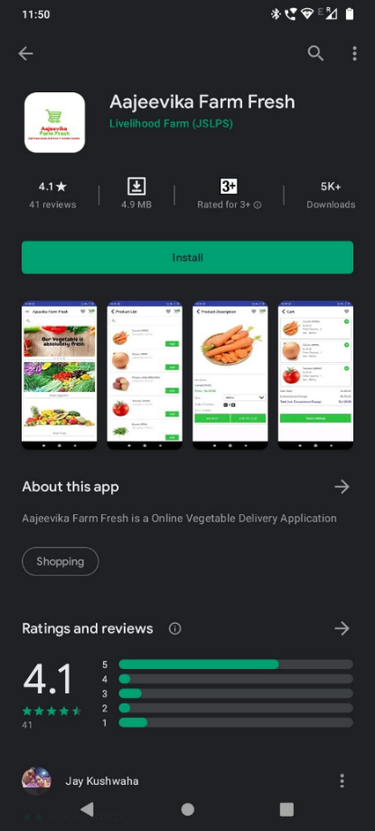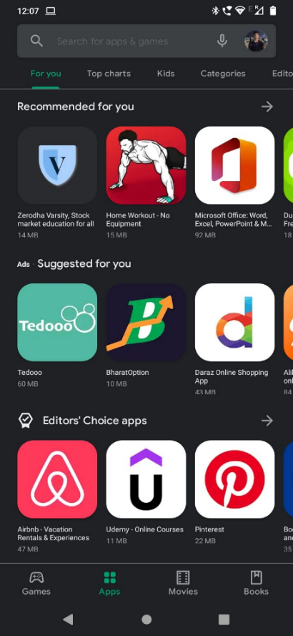

## Opening Application

Step 1: To find the application open your app drawer in android phone, and search “Ajeevika Seller”

Step 2: Click on “Ajeevika Seller” icon in the app drawer.

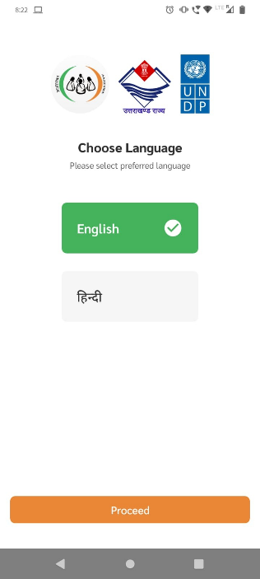Step 3: Choose the language of your choice.

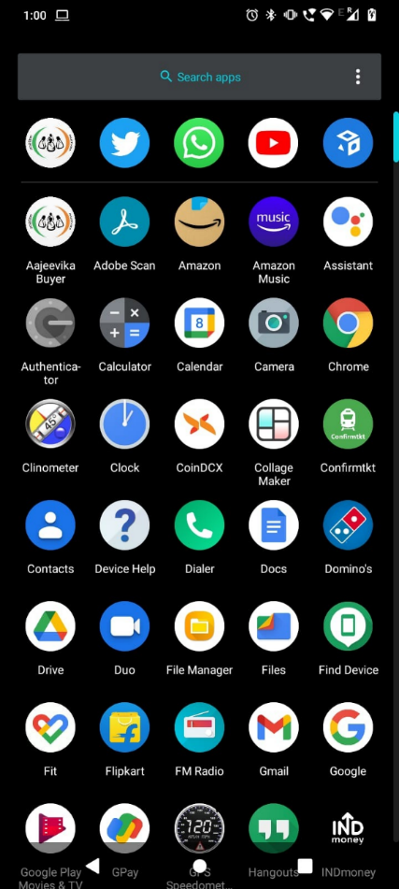

# User, Accounts & Profile

## Sign Up

When you open the application for the first time you will be greeted with the page shown below, To access the application you will need an account. To open the account follow the steps below:

Step 1: Click on “Click to Register” text on the bottom of the page.

Step 2: Fill in the required details viz a viz your Name, email ID, phone no., password (should be min of 8 characters).

Step 3: After filling all the details click on Check box for T&C & Privacy Policy and click on SignUp button.

Step 4: Enter OTP, received on your registered Phone No. and click on Verify button.

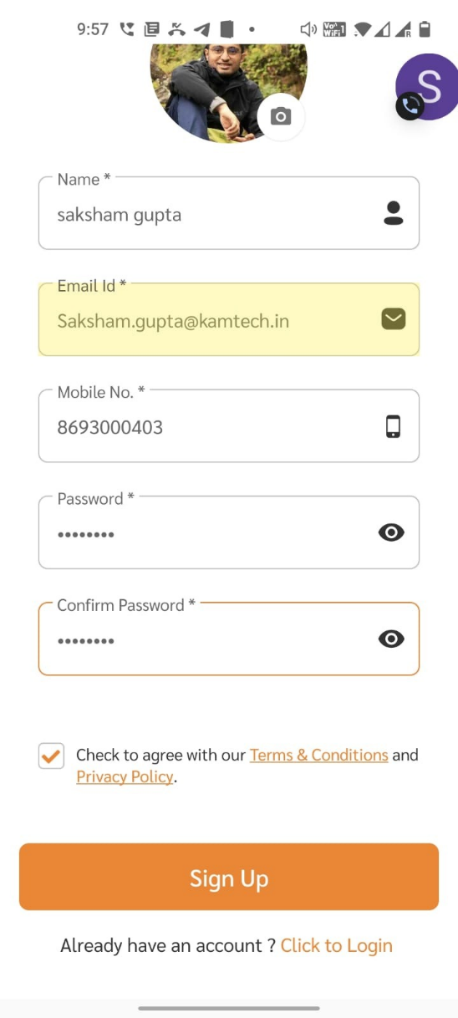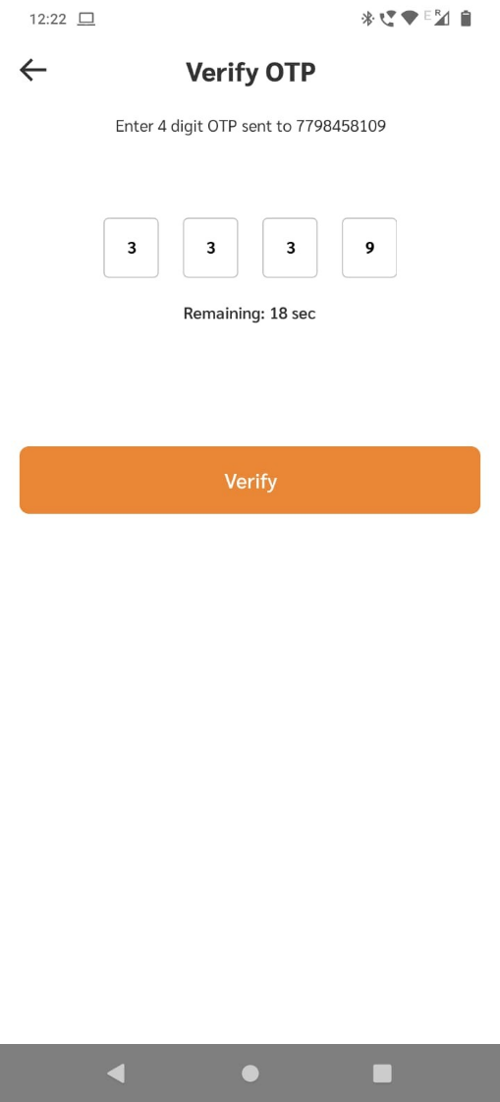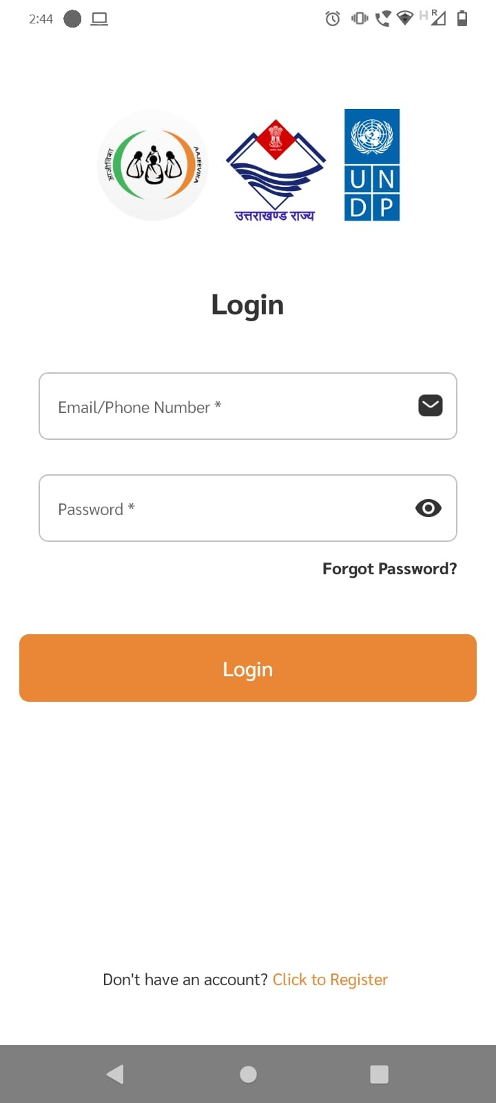

## Setting up account

Once you signup the next step is to upload your documents and set location, follow the steps for the same:

Step 1: Fill in your Aadhar No., Name, DOB, as well as upload aadhar card (both sides) for verification purpose.

Step 2: Fill in your current address as per the form given below then click on “Verify” button.

Step 3: Pin point your exact location on map and click on “Confirm Location & Proceed” button.

Step 4: Onto the next you have to select at least 5 interest, to match you withother SHG Individuals.

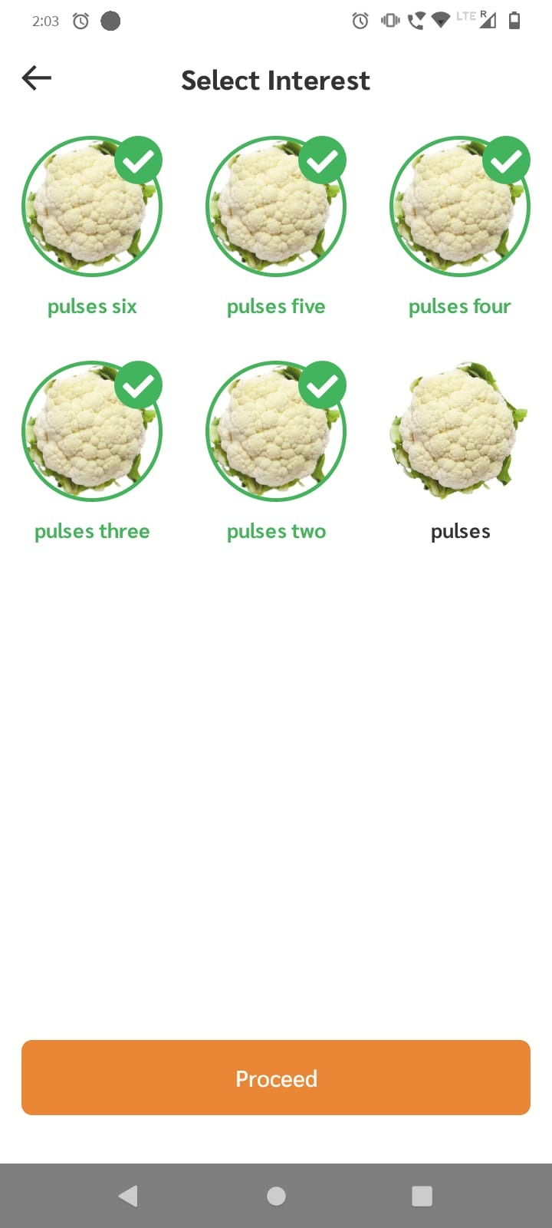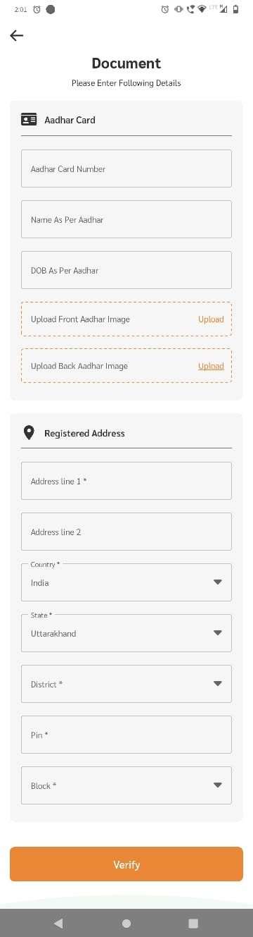

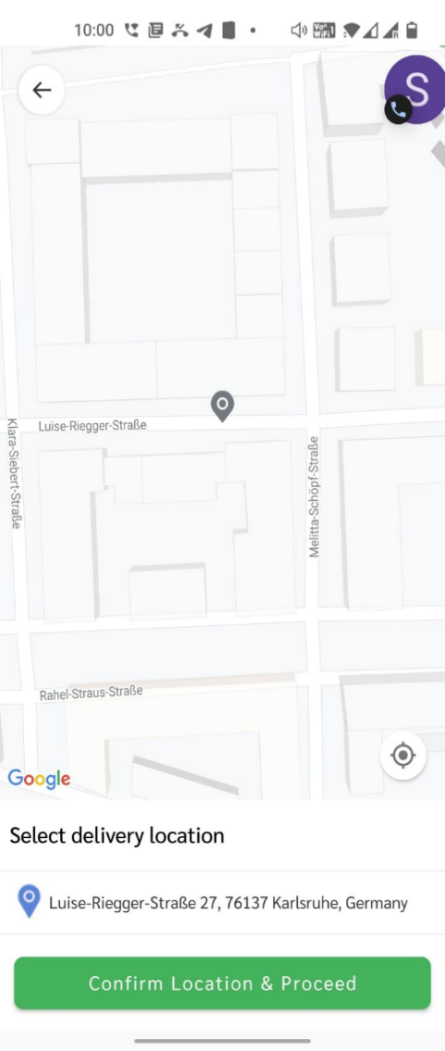

## Login & Logout

Once you create account you will be directly redirect into Home Page (which we will discuss below), but if you need to login/logout again follow the following steps:

Step 1: Open the application and enter your login credentials i.e email Id & password and click on Login button. You are successfully logged in.

Step 2: To logout click on menu button shown below, a side pane will pop up.

Step 3: Click on Logout button from the side pane.

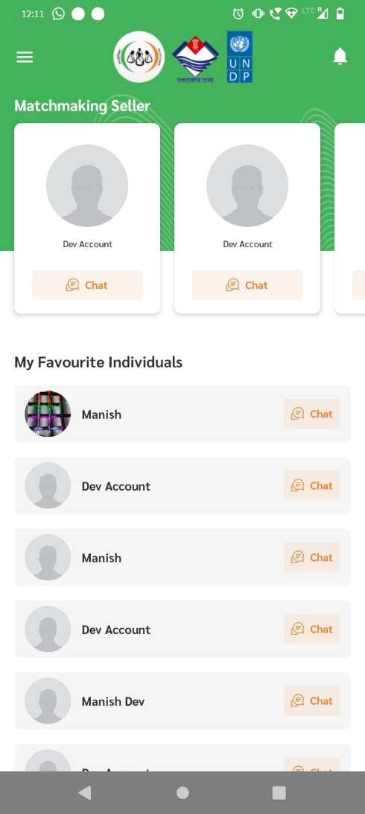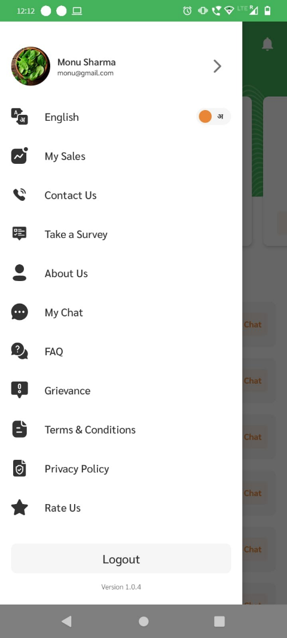



## Forget Password

If you forget your password, then don’t worry follow the following steps to change your password.

Step 1: Click on “forget password?” text shown below.

Step 2: Enter your registered mobile no. and click on Verify button

Step 3: Enter OTP received on your mobile no.

Step 4: Create new password and confirm your password and click on Save button.

Now you have successfully reset your password.

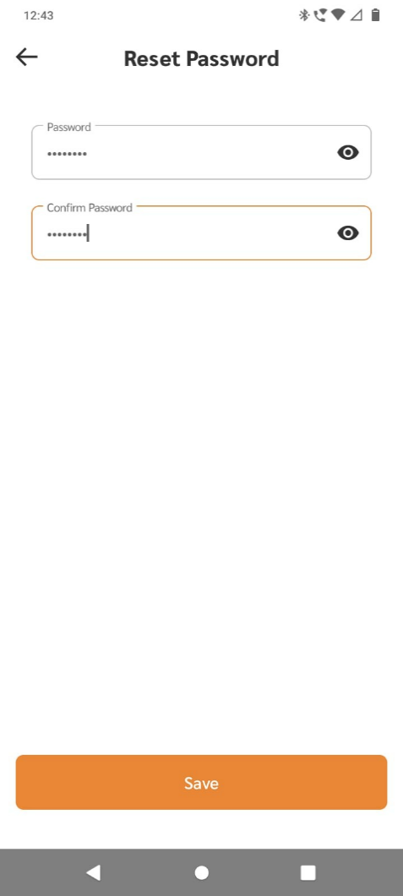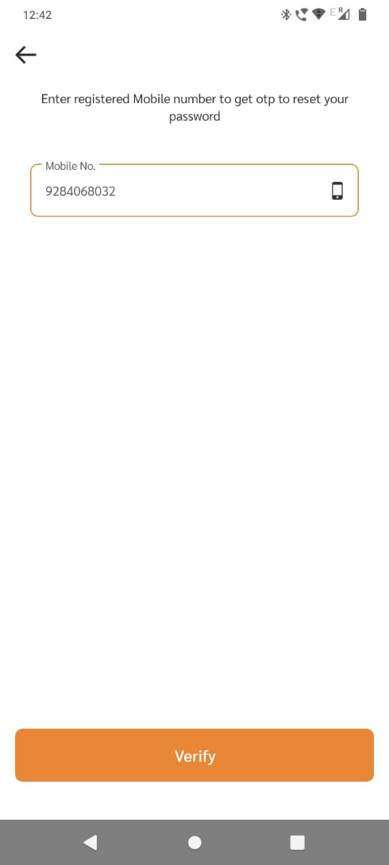

## Profile

The profile section will allow you to update user information.

Step 1: To go to profile page click on menu button and in the side-pane click on “My Profile” button.

Step 2: To update/change user information click on “Edit” button on top right corner.

Step 3: In Edit Profile, you can change your information i.e Organization name, member name, designation, email Id, mobile No., address etc.

Step 4: After making necessary changes click on “Save Changes” button.

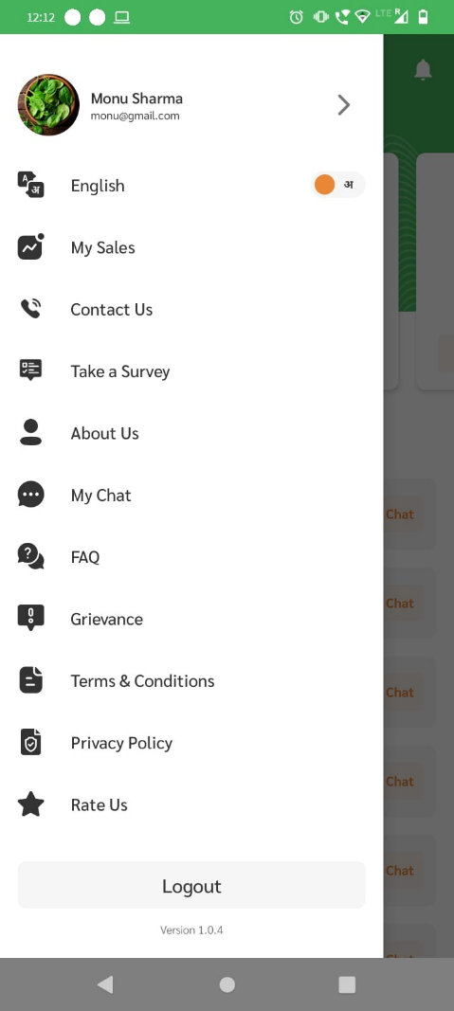

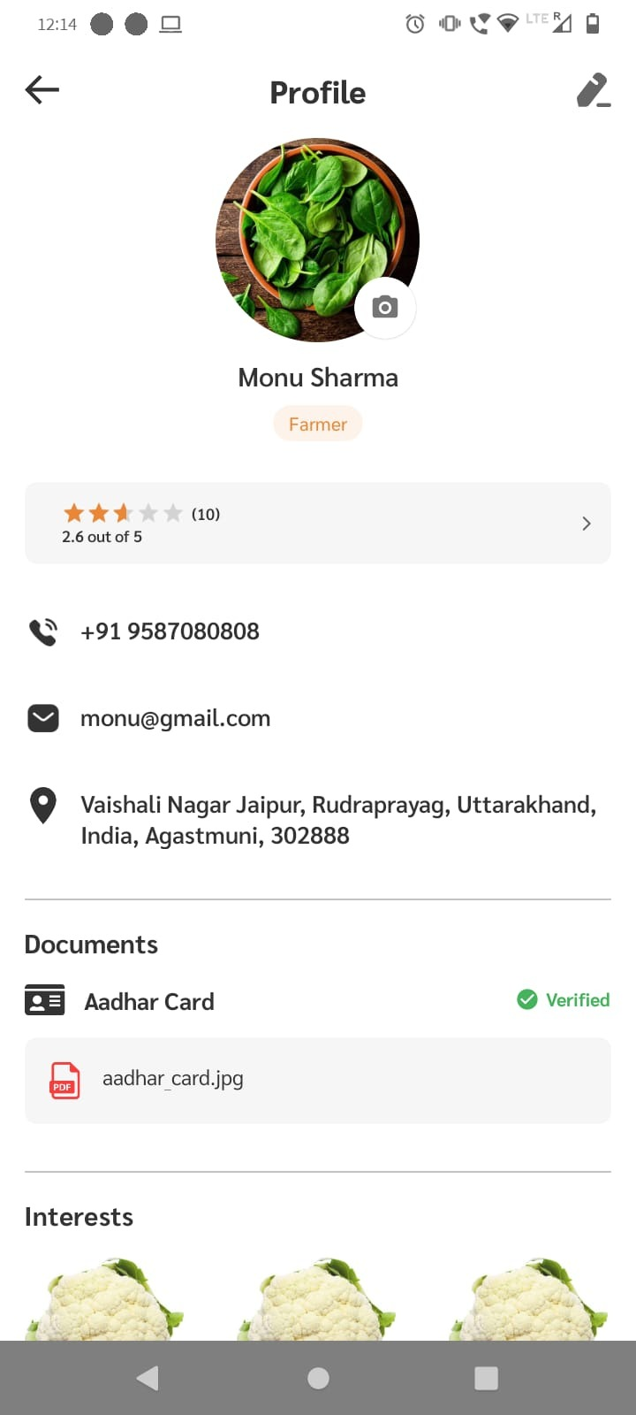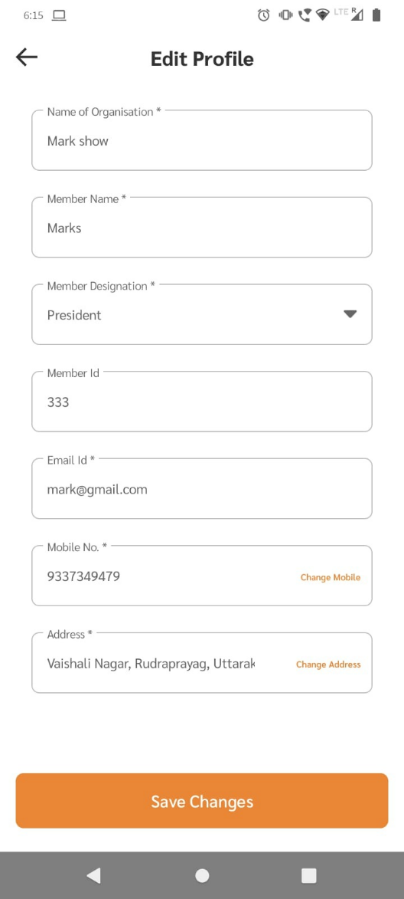

## Overview of Home Page

When you open the application, you will be greeted with this home page with lots of different buttons and features, all of them is explained below.

Based on interest selection of SHG Individual, he/she will be matched with other SHG individuals who have chosen similar interests

Menu Button

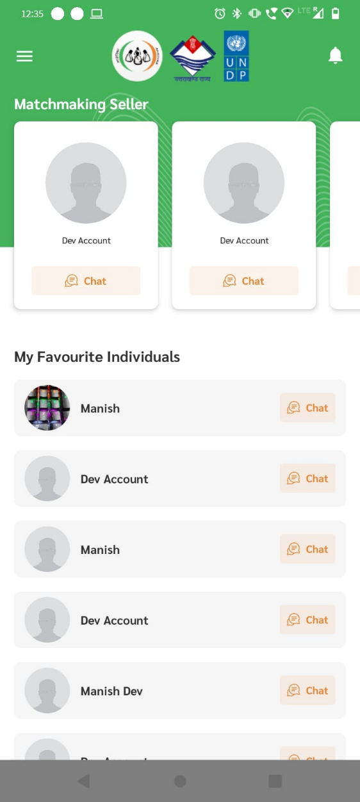

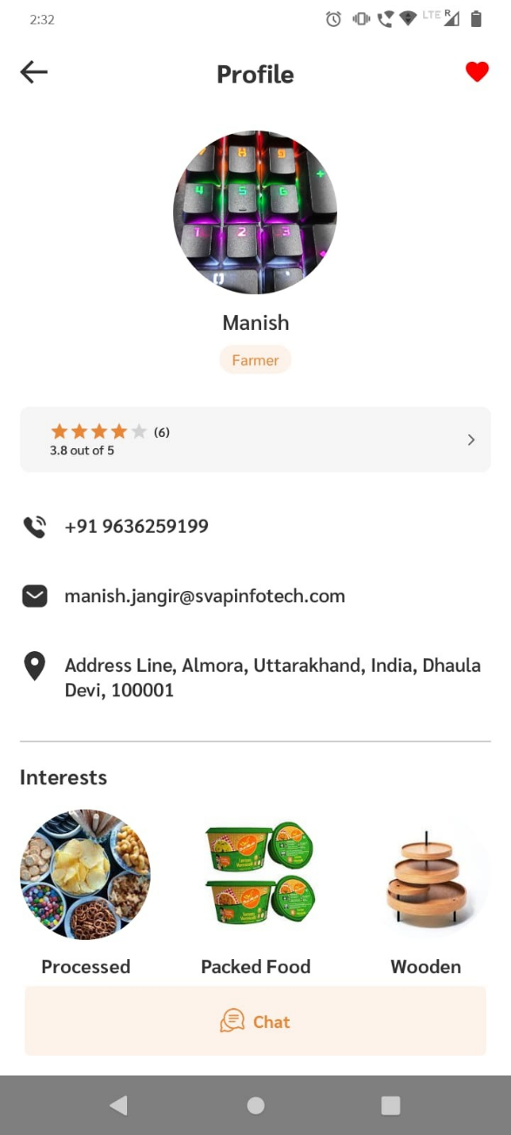

Favourite Individuals

To mark any SHG Individual as favourite click on heart icon

The SHG individuals which have been marked as favorites, will be shown here

SHG Individuals with similar interest

Notification Button

# Sales

## View Sales

To view sales follow the steps below:

Step 1: Click on menu button shown below to open side open.

Step 2: From the side menu click on “My Sales” button.

Step 3: Here you will find the list of all the sales, to view details of the sales click on the respective green arrow.

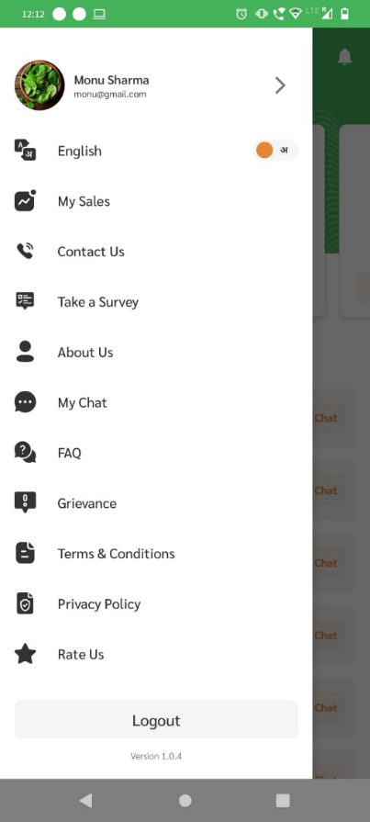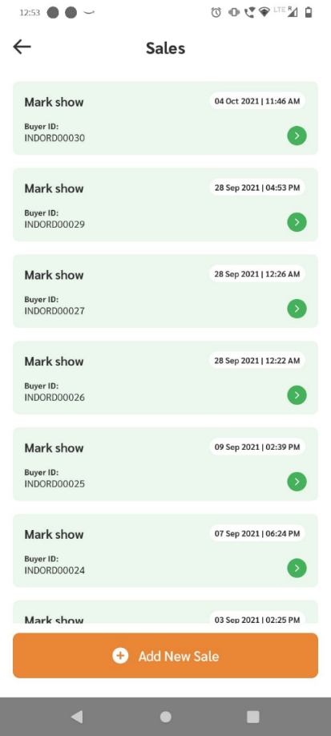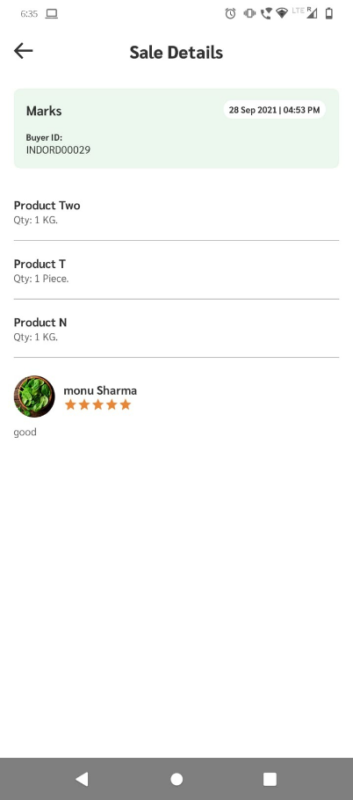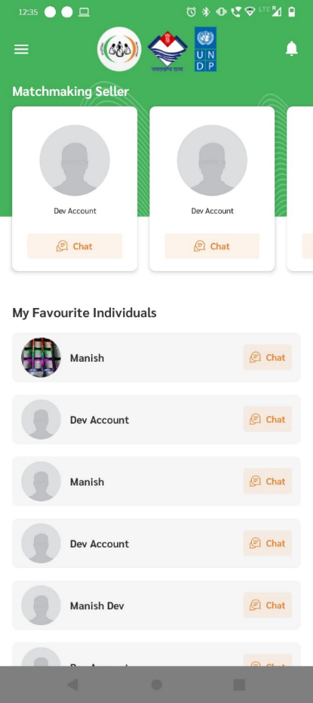

## Add New Sale

To add new sales for CLF follow the steps below:

Step 1: Go to “My Sales page as shown above in section 3.1.

Step 2: From the sales page click on “Add New Sale” button.

Step 3: In Add New Sale page select the CLF from the dropdown option.

Step 4: Now select products and quantity and click on “Done” button on bottom.

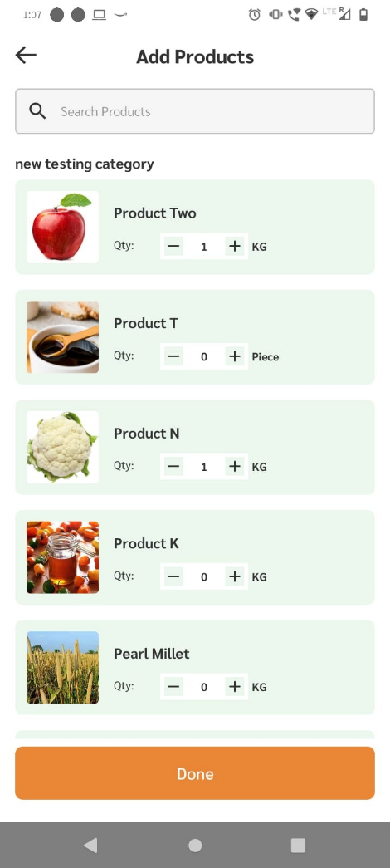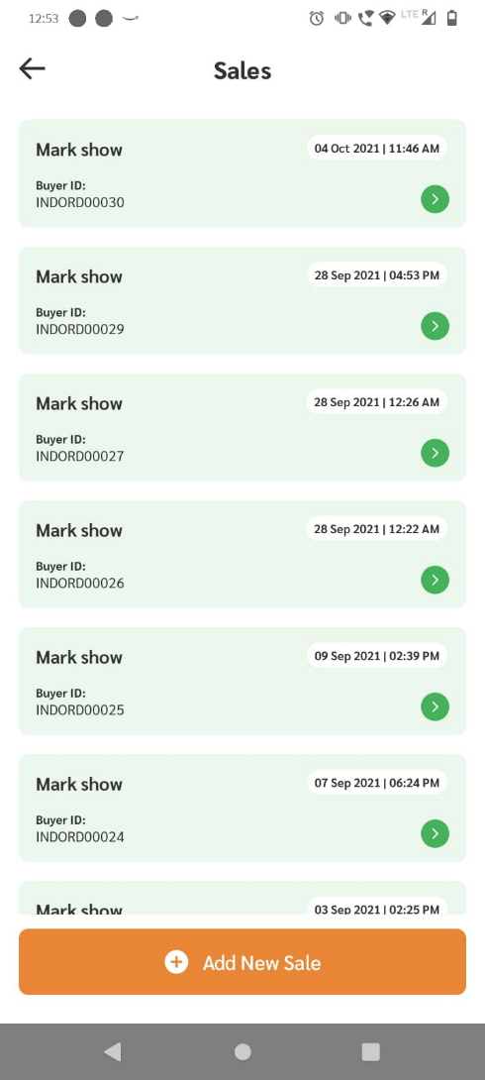

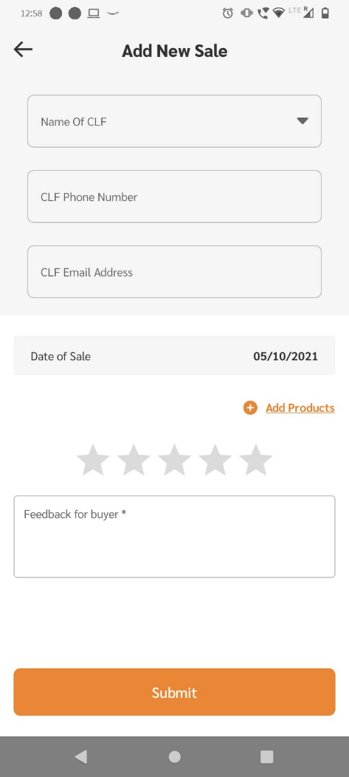

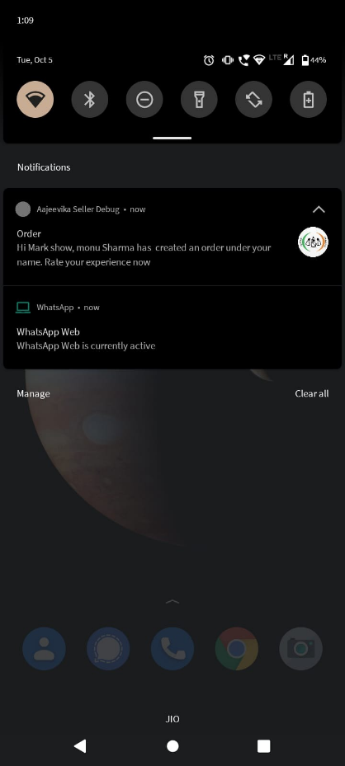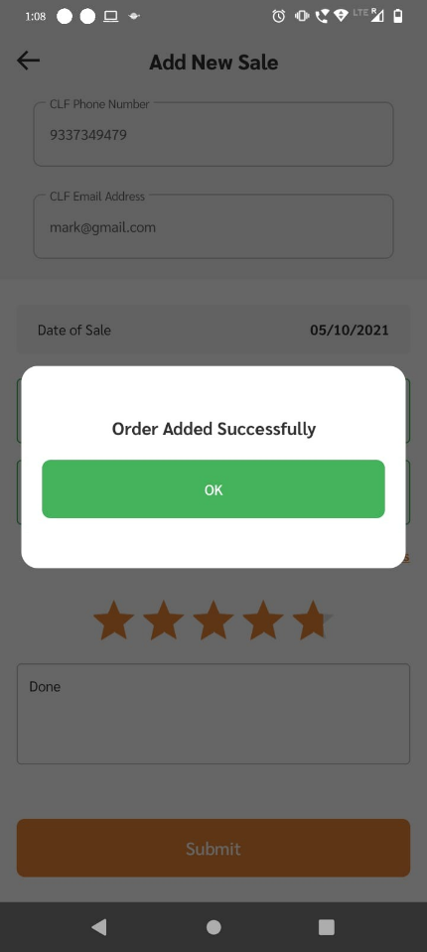 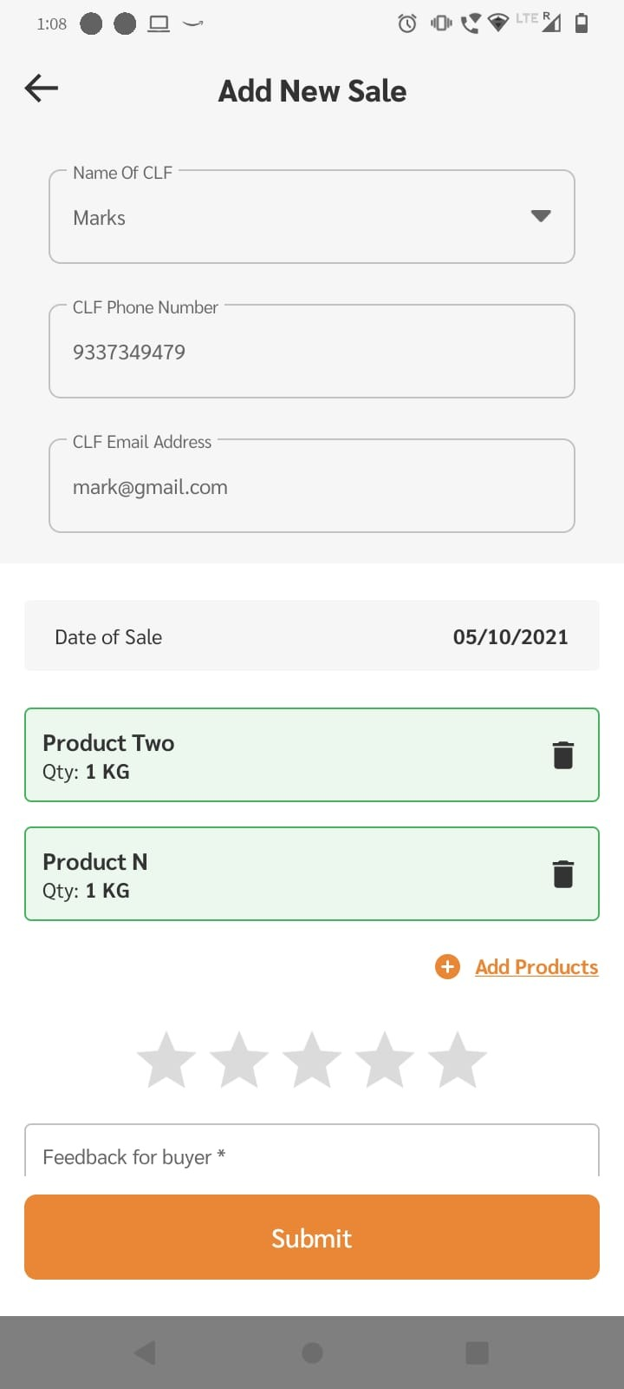

Step 5: After adding products add message for buyer as well as start rating.

Step 6: To complete the sale click on “Submit” button.

After addition of sale, respective CLF will get notification on the mobile App.

## Survey:

SHG Individuals can participate in surveys to participate in surveys follow the steps below:

Step 1: Click on menu button shown below to open side open.

Step 2: From the side menu click on “Take a Survey” button.

Step 3: Here you will find list of all surveys.

(Active Surveys are shown in green and pas t surveys are shown in red)



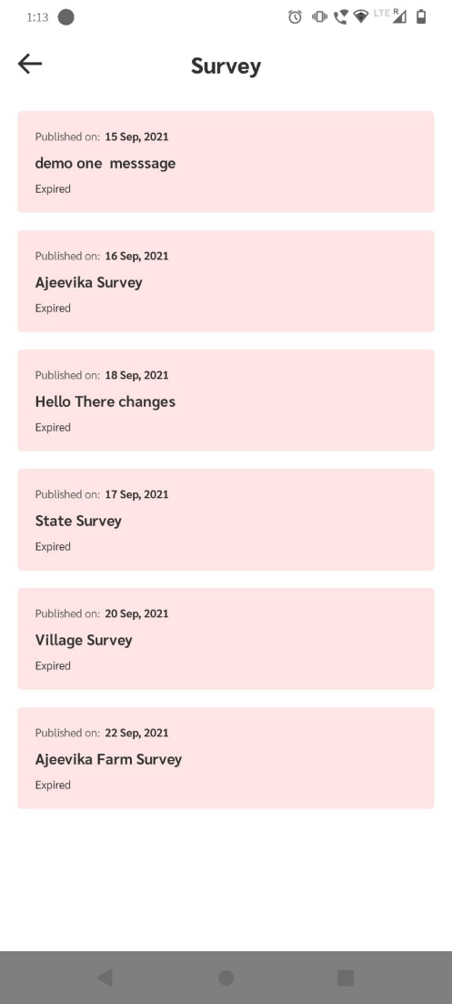

## My Chats:

SHG Individuals can chat with other SHG’s with similar interests, to access chat follow the steps below:

Step 1: Click on menu button shown below to open side open.

Step 2: From the side menu click on “My Chat” button.

Step 3: Select the CLF you want to chat with.

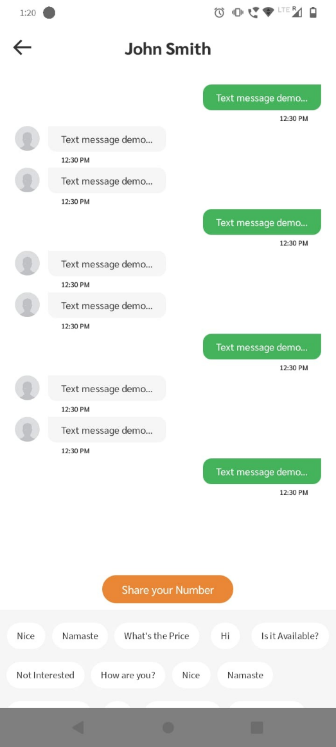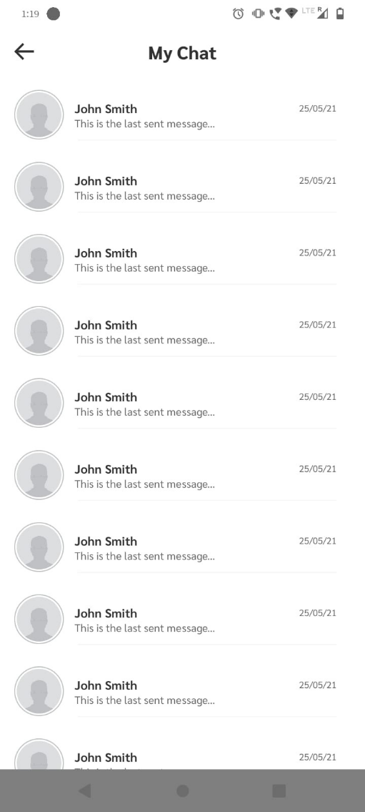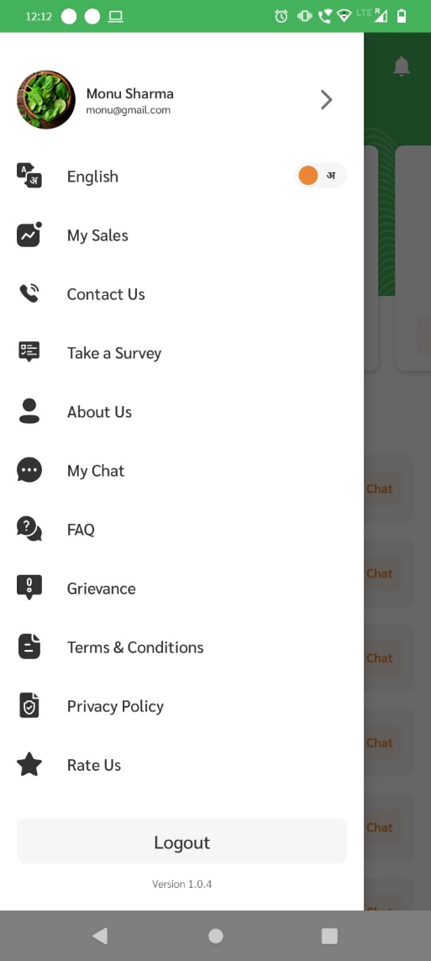

## FAQs:

SHG individual application has FAQs section, to go to FAQs follow the steps below:

Step 1: Click on menu button shown below to open side open.

Step 2: From the side menu click on “FAQ” button.

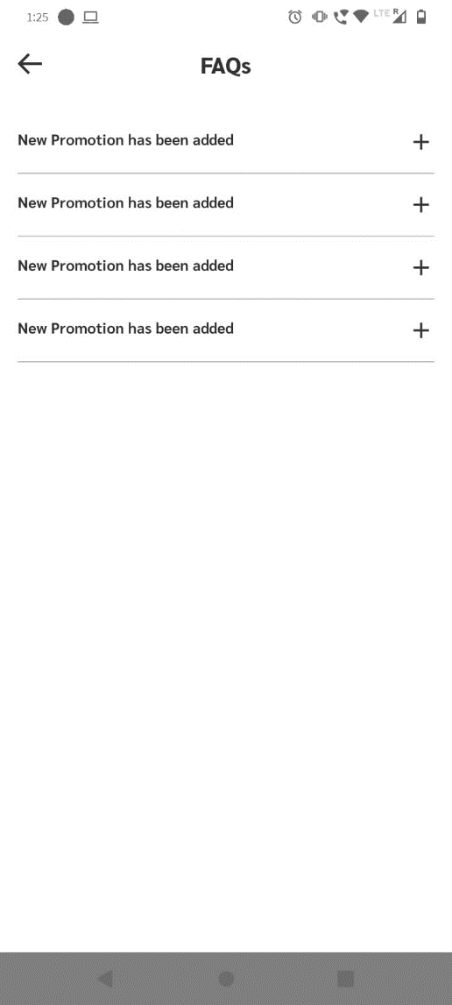

## Change Language

To change language follow the steps below:

Step 1: Click on menu button on homepage

Step 2: From side-pane click language toggle button.

Now the language of the entire app will change.

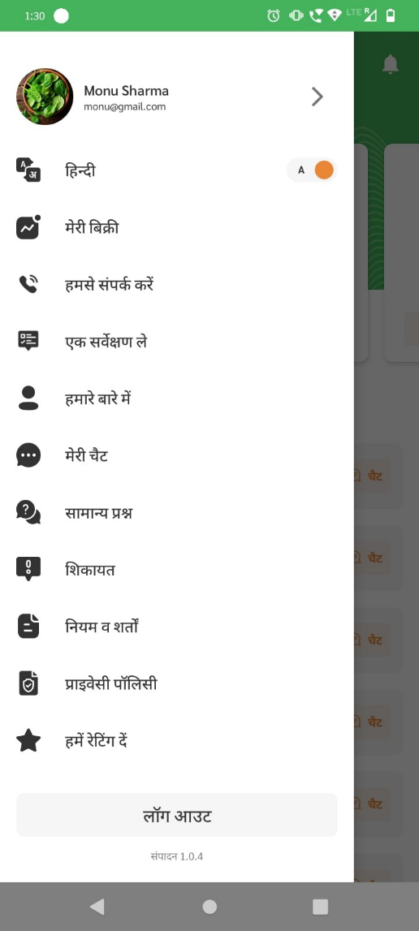

## Grievances

In order to raise an issue users can built in grievances section in the app, In order to access grievances follow the steps below:

Step 1: Go to side pane and click on “Grievances”

Step 2: Click on “Raise Ticket” at the buttom.

Step 3: Select your issue from dropdown, and explain in the text field below

Step 4: Click on “Submit”

